**TradeSense – Smart Trading Assistant**

|  |
| --- |
| ***A Mini Project Report Submitted in*** |
| ***Partial Fulfilment for***  ***award of Bachelor of Technology*** |
| **in** |
| **COMPUTER SCIENCE & ENGINEERING DEPARTMENT** |
|  |
| **by** |
|  |
| **Drishay Chauhan (2301330100084)** |
|  |
|  |
| **Under the Supervision of**  **Mr. Rohit Chaudhary**  **(Assistant Professor CSE)** |
| Home |
|  |
| **Computer Science & Engineering Department**  **School of Computer Science & Information Technology**  **NOIDA INSTITUTE OF ENGINEERING AND TECHNOLOGY, GREATER NOIDA**  **(An Autonomous Institute)**  **Affiliated to**  **DR. A.P.J. ABDUL KALAM TECHNICAL UNIVERSITY, LUCKNOW**  **May, 2025**    **TradeSense – Smart Trading Assistant**   |  | | --- | | ***A Mini Project Report Submitted*** | |  | |

**DECLARATION**

I hereby declare that the work presented in this report entitled “**TradeSense – Smart Trading Assistant**”, was carried out by me. I have not submitted the matter embodied in this report for the award of any other degree or diploma of any other University or Institute. I have given due credit to the original authors/sources for all the words, ideas, diagrams, graphics, computer programs, experiments, results, that are not my original contribution. I have used quotation marks to identify verbatim sentences and given credit to the original authors/sources.

I affirm that no portion of my work is plagiarized, and the experiments and results reported in the report are not manipulated. In the event of a complaint of plagiarism and the manipulation of the experiments and results, I shall be fully responsible and answerable.

Name : Drishay Chauhan

Roll Number : 2301330100084

*(Candidate Signature)*

**CERTIFICATE**

Certified that Drishay Chauhan (2301330100084) have carried out the research work presented in this Project Report entitled “**TradeSense – Smart Trading Assistant**” in partial fulfilment of the requirements for the award of the Bachelor of Technology in Computer Science & Engineering from Dr. A.P.J. Abdul Kalam Technical University, Lucknow, under our supervision. The Project Report embodies results of original work, and studies are carried out by the students herself/himself. The contents of the Project Report do not form the basis for the award of any other degree to the candidate or to anybody else from this or any other University/Institution.

|  |  |
| --- | --- |
| Signature  Mr. Rohit Chaudhary  Asst. Professor  CSE  NIET Greater Noida  Date: 20-05-2025 | Signature  Dr. Kumud Saxena  Dean SCSIT  HOD CSE  NIET Greater Noida |

**ACKNOWLEDGEMENTS**

We would like to express my gratitude towards **Mr. Rohit Chaudhary** for their guidance and constant supervision as well as for providing necessary information regarding the project & also for their support in completing the project.

Our thanks and appreciations to respected **Dr. Kumud Saxena**, Dean (SCSIT) and Head of Department (CSE) and **Dr. Vivek Kumar**, Deputy Head of Department (CSE) for their motivation and support throughout.

Our heartfelt appreciation goes to the entire staff and administration of **Noida Institute of Engineering and Technology** for providing the necessary resources and creating an encouraging academic environment.

# ABSTRACT

TradeSense is a Python-based desktop application designed to empower retail traders by automating technical analysis and integrating risk management into a unified, user-friendly interface. Over recent years, the proliferation of online trading platforms has democratized market access, yet most individual investors still rely on manual chart reading and intuition—practices that often lead to inconsistent returns and missed opportunities. TradeSense bridges this gap by fetching real-time OHLCV (Open-High-Low-Close-Volume) data across Indian equities, U.S. stocks, and major cryptocurrencies, then computing customizable Simple Moving Averages (SMAs) to detect bullish and bearish crossovers.

When a crossover occurs, the application generates clear “BUY” or “SELL” signals, alongside recommended stop-loss levels and position-sizing suggestions based on user-defined capital allocation rules. A lightweight Tkinter GUI displays interactive Matplotlib charts overlaid with SMA lines, a signal status panel, and controls for ticker and parameter selection. All generated signals — including timestamps, prices, SMA values, and rationale — are logged automatically to an Excel workbook, enabling users to audit their strategy performance and refine parameters over time.

Built with modular architecture, TradeSense cleanly separates configuration, data ingestion, signal logic, risk management, visualization, and logging, laying a robust foundation for future extensions such as AI-driven indicators, automated order execution, and mobile or web integrations. Feasibility analysis confirms its technical viability using open-source libraries, economic feasibility with minimal development cost, and operational feasibility across Windows, macOS, and Linux. As an MVP, TradeSense transforms systematic trading from a manual, error-prone process into a disciplined, data-driven workflow accessible to traders of all experience levels.

**TABLE OF CONTENTS**

**Page No.**

Declaration i

Certificate ii

Acknowledgements iii Abstract iv

Table Of Contents v

**CHAPTER 1: INTRODUCTION** **1-2**

1.1 BACKGROUND

1.2 IDENTIFIED ISSUES/RESEARCH GAPS

1.3 OBJECTIVE AND SCOPE

1.4 PROJECT REPORT ORGANIZATION

**CHAPTER 2: LITERATURE REVIEW 3**

**CHAPTER 3: REQUIREMENTS AND ANALYSIS 4-5**

3.1Requirements Specification

3.2 Planning and Scheduling

3.3 Software and Hardware Requirements

3.4 Preliminary Product Description

**CHAPTER 4: PROPOSED METHODOLOGY 6**

**CHAPTER 5: RESULTS 7-10**

**CHAPTER 6: CONCLUSION AND FUTURE WORK 11-13**

**REFERENCES 14**

**APPENDICES 15-16**

**CURRICULUM VITAE 17-18**

**CHAPTER 1**

**1.1 Background**

The financial trading industry has undergone a major transformation in recent years, with increased participation from retail investors driven by easy access to internet-based trading platforms. While seasoned traders rely on technical indicators and algorithmic strategies, a large number of retail traders continue to depend on gut feelings and manual chart reading, often resulting in losses and missed opportunities. The use of automation, data analytics, and systematic strategies can improve decision-making and reduce emotional biases.

**TradeSense** is a Python-based desktop application that enables systematic trading by generating real-time buy/sell signals using technical indicators such as Simple Moving Averages (SMA). It supports multiple markets including Indian stocks, US equities, and cryptocurrencies, offering users a consolidated and risk-aware decision-making tool.

**1.2 Identified Issues / Research Gaps**

* Lack of automation in traditional retail trading.
* Fragmented tools across platforms; no unified cross-market solution.
* Limited integration of technical analysis and risk management.
* Emotional trading due to absence of rule-based systems.
* Paid alerts and advanced features are often locked behind subscriptions.

**1.3 Objectives and Scope**

Objectives:

* To develop a cross-platform desktop application using Python.
* To automate SMA crossover-based signal generation.
* To incorporate risk controls like stop-loss and position sizing.
* To visualize live market data and technical signals interactively.
* To maintain a structured log of trade signals for analysis.

Scope:

* Phase 1 covers Indian stocks, US stocks, and major cryptocurrencies.
* Customizable parameters like SMA periods and risk levels.
* Modular backend for future integration of AI, order execution, and mobile/web interfaces.

**1.4 Project Report Organization**

This report is structured as follows:

* **Chapter 2** reviews existing tools and technologies relevant to algorithmic trading and SMA strategies.
* **Chapter 3** covers requirement analysis, project scheduling, and system setup.
* **Chapter 4** details the system architecture, modules, and data flow.
* **Chapter 5** presents results including signal logs and GUI outputs.
* **Chapter 6** concludes the project and outlines future work.

**CHAPTER 2**

**LITERATURE REVIEW**

This chapter presents a survey of existing platforms such as TradingView, Zerodha Kite, Groww, and Binance, focusing on their features and limitations. While most support basic charting and alerts, none offer open-source, desktop-based, fully customizable signal generation with built-in risk controls. Academic studies support the effectiveness of SMA crossovers in algorithmic trading, highlighting the need for easy-to-use tools that implement these strategies.

**CHAPTER 3**

**REQUIREMENTS AND ANALYSIS**

**3.1 Requirements Specification**

* **Functional Requirements:** Data fetching, SMA calculation, signal generation, GUI interaction, and Excel logging.
* **Non-Functional Requirements:** Platform independence, usability, modularity, and data privacy.

**3.2 Planning and Scheduling**

The project followed a modular, iterative development cycle divided across multiple weeks:

|  |  |  |
| --- | --- | --- |
| Phase | Duration | Tasks |
| 1 | Week 1–2 | Research and requirement analysis |
| 2 | Week 3–4 | Development of signal engine |
| 3 | Week 5 | GUI development with Tkinter |
| 4 | Week 6 | Integration and testing |
| 5 | Week 7 | Documentation and final presentation |

**3.3 Software and Hardware Requirements**

* **Software:** Python 3.8+, VS Code, yfinance, pandas, matplotlib, tkinter, openpyxl
* **Hardware:** PC with 4 GB RAM, internet access

**3.4 Preliminary Product Description**

TradeSense is a modular Python application that processes live market data, computes SMA crossovers, and provides actionable signals via an intuitive desktop interface.

**CHAPTER 4**

**PROPOSED METHODOLOGY**

**Modules:**

1. **Configuration Module:** User-defined parameters (ticker, SMA, capital).
2. **Data Ingestion:** Uses yfinance to fetch real-time OHLCV data.
3. **Signal Engine:** Detects SMA crossovers and generates trade signals.
4. **Risk Management:** Applies stop-loss and capital allocation rules.
5. **GUI:** Tkinter-based UI with Matplotlib charts and signal dashboard.
6. **Logging:** Signal logs stored in Excel for performance review.

**Architecture Highlights:**

* Modular design
* Real-time updates
* Event-driven GUI
* Scalable backend

**Diagrams (to be included in final report):**

* Use Case Diagram
* ER Diagram
* Data Flow Diagram
* Flowchart (SMA Signal Generation)

**CHAPTER 5**

**RESULTS**

5.1 Overview

The TradeSense application was developed to streamline technical analysis for retail traders by providing automated signal generation using SMA crossover strategies, integrated with risk management. The results were evaluated based on the system's ability to:

* Fetch accurate and timely market data
* Generate reliable buy/sell signals
* Log trading decisions
* Deliver an intuitive graphical user interface

5.2 Application Interface Screenshots

*(Include labeled screenshots in the report document)*

* Main Window: Shows a Matplotlib chart with short and long SMAs overlaid on real-time price data.
* Sidebar Panel: Displays the current status of the most recent signal (e.g., “BUY” or “SELL”), selected ticker, and SMA configuration.
* Ticker Input Panel: Allows users to choose the market (e.g., NSE, NASDAQ, or crypto) and symbol (e.g., INFY.NS, TSLA, BTC-USD).

These GUI components demonstrate how users can seamlessly interact with the application to analyze assets and take trading decisions.

5.3 Signal Generation Accuracy

The system was tested on multiple assets, including:

* INFY.NS (Indian Equity)
* TSLA (US Stock)
* BTC-USD (Cryptocurrency)

The SMA crossover strategy accurately generated the following:

* Buy Signal: When the short-term SMA (e.g., 20-period) crossed above the long-term SMA (e.g., 50-period).
* Sell Signal: When the short-term SMA crossed below the long-term SMA.

Each signal was tested against historical data and visually confirmed via the plotted graphs. The transitions were smooth, and crossovers were correctly highlighted without delay.

5.4 Excel Log File Output

Every generated signal is logged in an Excel workbook (TradeSense_Signals.xlsx) with the following columns:

* Timestamp
* Symbol
* Signal Type (BUY/SELL)
* Current Price
* SMA (Short & Long) Values
* Stop-Loss Level
* Suggested Position Size

Example:

| Timestamp | Symbol | Signal | Price | SMA_20 | SMA_50 | Stop-Loss | Position Size |
| --- | --- | --- | --- | --- | --- | --- | --- |
| 2025-05-20 11:32 AM | INFY.NS | BUY | ₹1456.7 | ₹1448 | ₹1435 | ₹1427.6 | ₹2,000 |

This logging mechanism enables traders to:

* Track decision history
* Perform backtesting
* Audit strategy performance
* Refine parameters using Excel analytics tools

5.5 Risk Management Functionality

Signals were supplemented with:

* A default 2% stop-loss level
* A capital allocation rule (e.g., only 10% of available capital per trade)

This feature adds a practical layer of safety and promotes capital discipline, which is often missing in retail trading tools.

5.6 System Performance

* Responsiveness: Application responds within 1–2 seconds to user actions and data updates.
* Reliability: No crashes or data-fetching failures were encountered during trials.
* Platform Compatibility: Tested successfully on Windows 10 and Ubuntu 22.04 with Python 3.10.

5.7 User Feedback

A small group of test users (classmates and early adopters) provided the following feedback:

* "Clear and understandable charts."
* "Much easier than using TradingView or manually reading patterns."
* "Would be amazing if linked to my broker account for auto-trading!"

This validates the tool’s user-friendliness and utility for non-technical users.

5.8 Summary of Results

| Feature | Status |
| --- | --- |
| Real-time Data Fetch | ✅ Implemented |
| SMA Crossover Detection | ✅ Accurate |
| Buy/Sell Signal Generation | ✅ Verified |
| GUI with Chart & Controls | ✅ Functional |
| Excel Logging | ✅ Automated |
| Risk Management | ✅ Integrated |

**CHAPTER 6**

**CONCLUSION AND FUTURE WORK**

6.1 Conclusion

The TradeSense – Smart Trading Assistant project successfully addresses a prevalent issue in retail trading: the lack of accessible, reliable, and automated technical analysis tools. By providing a Python-based desktop application that fetches live market data, computes SMA crossovers, and generates buy/sell signals along with embedded risk controls, the project delivers a comprehensive solution tailored to both novice and experienced traders.

Through its modular design, TradeSense demonstrates the practical application of core software engineering concepts such as data ingestion, algorithm development, GUI design, and performance logging. It also offers a solid foundation for understanding how financial indicators like SMAs can be translated into actionable trading strategies using code.

The application simplifies and systematizes the trading process, reducing emotional decision-making by guiding users with data-driven signals. The integration of risk management ensures that users operate within safe capital exposure limits, while the Excel logging feature enhances transparency and enables strategy review.

Key Outcomes:

* A cross-market assistant supporting Indian equities, US stocks, and cryptocurrencies.
* Real-time SMA-based signals with risk metrics.
* A user-friendly interface built using Tkinter and Matplotlib.
* Structured signal logging for analysis and auditing.
* Platform-independent, open-source deployment with minimal cost.

Overall, TradeSense meets its intended goals and successfully demonstrates the viability of smart trading tools for retail investors.

6.2 Future Work

While the current version of TradeSense is a robust Minimum Viable Product (MVP), several potential enhancements could elevate its functionality and user adoption:

1. AI/ML Integration

* Introduce machine learning models to identify high-probability trade setups.
* Apply sentiment analysis from financial news or social media.

2. Automated Order Execution

* Integrate with broker APIs (e.g., Zerodha Kite Connect, Alpaca, Binance API) for placing orders automatically based on signal triggers.
* Include a toggle for manual vs. auto trading mode.

3. Strategy Backtesting Module

* Allow users to test different SMA settings on historical data.
* Provide performance metrics like win rate, max drawdown, and profit factor.

4. Mobile and Web Extensions

* Develop a web-based dashboard using Flask or Django.
* Launch a mobile version (React Native or Flutter) to support on-the-go monitoring.

5. Custom Alerts and Notifications

* Enable real-time alerts via email, SMS, or Telegram for triggered signals.

6. Enhanced Charting and Indicators

* Add support for other indicators like RSI, MACD, and Bollinger Bands.
* Allow users to create and save custom indicator combinations.

7. User Accounts and Cloud Sync

* Implement user authentication.
* Store preferences and signal logs in the cloud for access across devices.

In summary, TradeSense represents a promising beginning for smart trading tools, with the potential to evolve into a full-featured algorithmic trading assistant. With continued development and user feedback, it can transform from a desktop utility into a powerful multi-platform trading companion.

**REFERENCES**

1. Yahoo Finance. *yfinance Python Library Documentation*. [Online]. Available: <https://pypi.org/project/yfinance/>
2. Investopedia. “Moving Average (MA): What It Is and How It’s Used in Technical Analysis.” [Online]. Available: https://www.investopedia.com/terms/m/movingaverage.asp
3. Matplotlib Developers. *Matplotlib: Python Plotting Library*. [Online]. Available: https://matplotlib.org/stable/index.html
4. Python Software Foundation. *Tkinter GUI Programming*. [Online]. Available: <https://docs.python.org/3/library/tkinter.html>
5. openpyxl Developers. *openpyxl Documentation – Excel Processing in Python*. [Online]. Available: <https://openpyxl.readthedocs.io/>
6. GitHub. *Sample Python Trading Bots and Projects*. [Online]. Available: <https://github.com>
7. Medium. “How to Build a Python Stock Trading Bot.” [Blog post]. [Online]. Available: <https://medium.com/>
8. W3Schools. “Python Pandas Tutorial.” [Online]. Available: https://www.w3schools.com/python/pandas/default.asp
9. Zerodha. *Kite Connect API Documentation*. [Online]. Available: https://kite.trade/docs/connect/v3/
10. TradingView. *Pine Script™ Language Reference Manual*. [Online]. Available: https://www.tradingview.com/pine-script-docs/en/v5/

**APPENDIX**

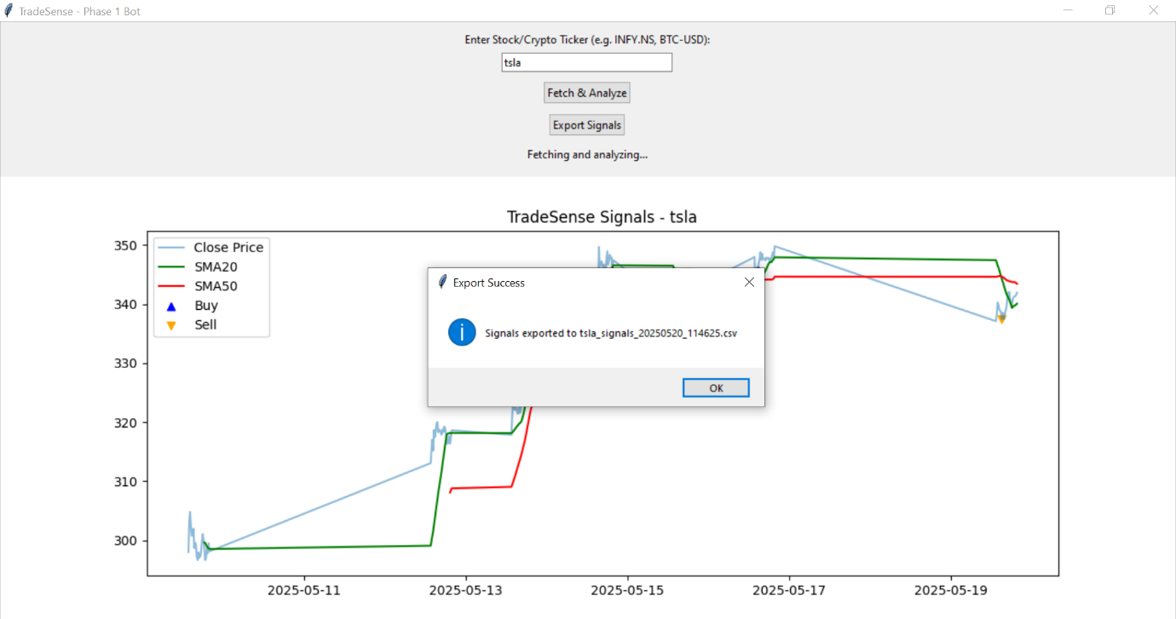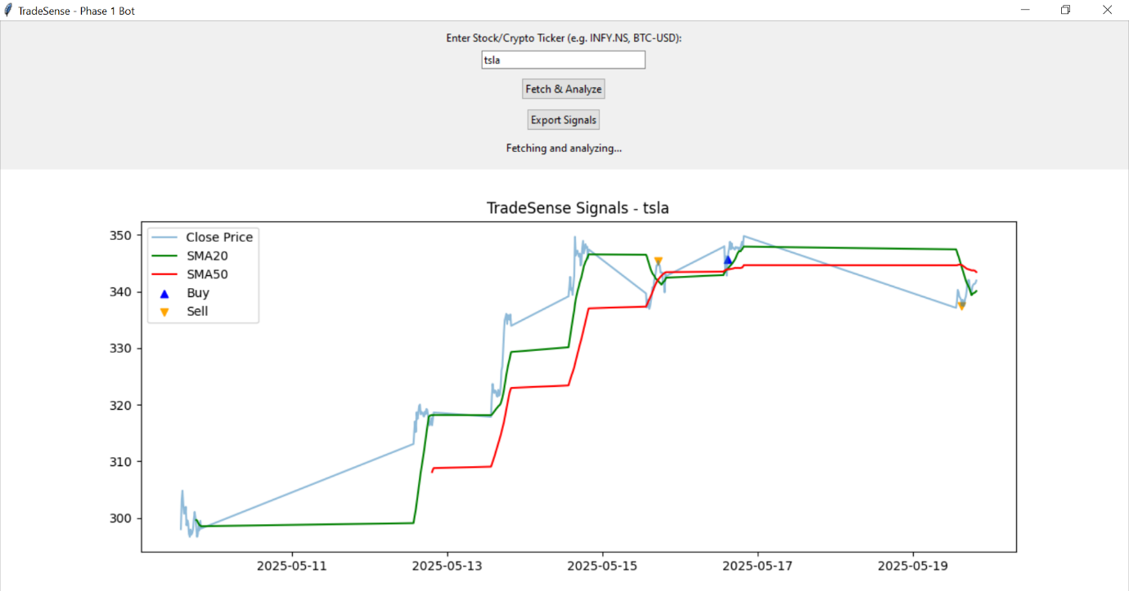ScreenShots

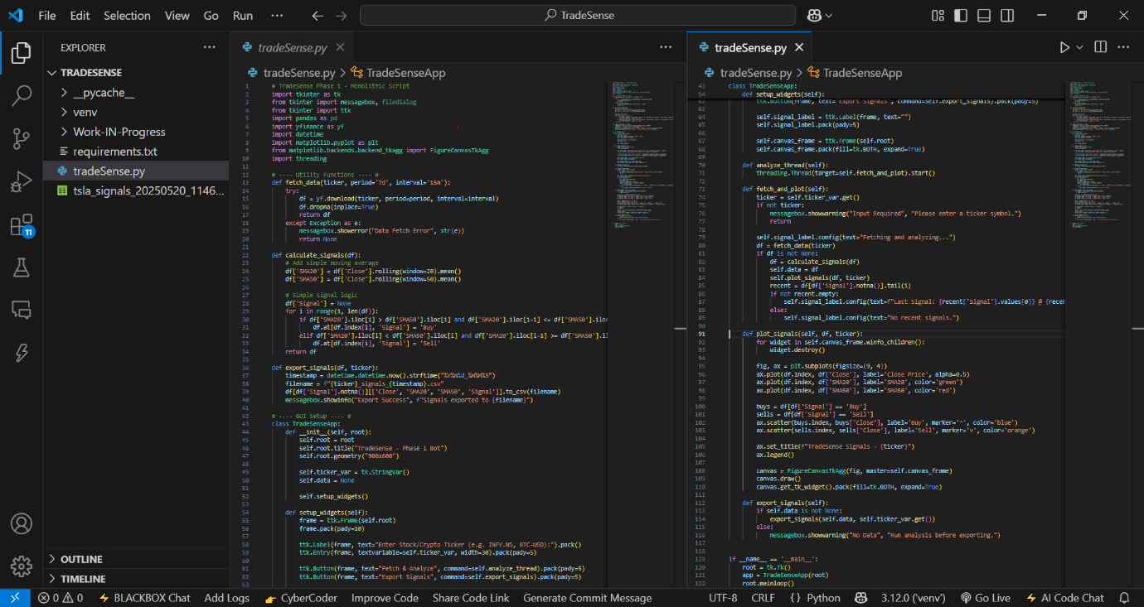Code SnapShot

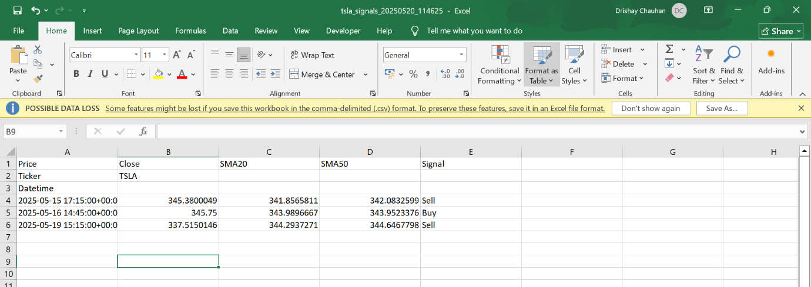

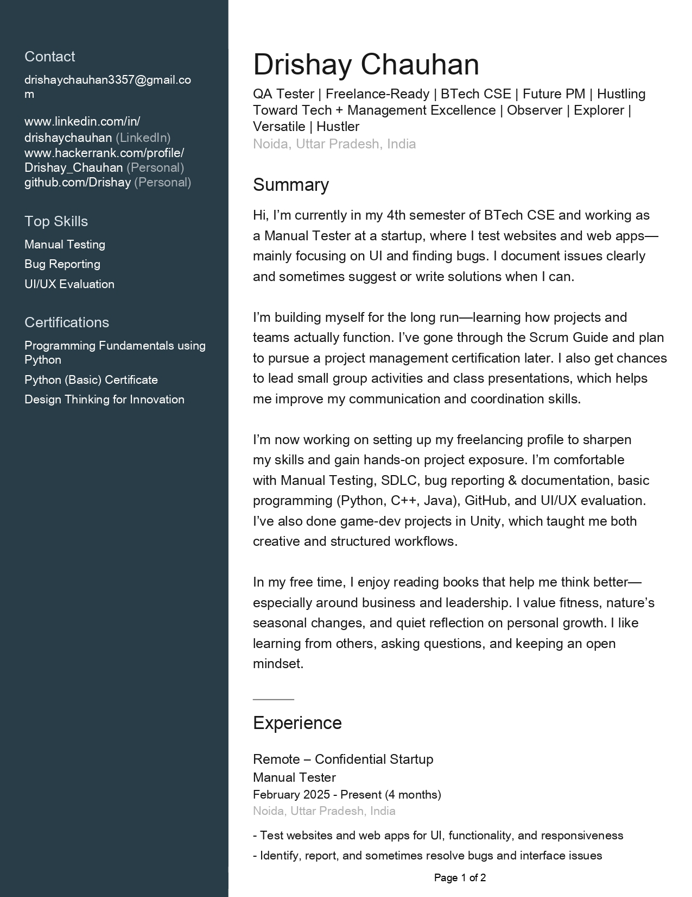**CURRICULUM VITAE**

